# CMGC Web Site User Guide

(Oct 9, 2016)

## Updating PDFs

The constitution, tournament manual, and membership application are PDF files. In WordPress, these files are part of Media. After logging into WordPress, click on the **Media** button. You’ll see these documents as well as other files

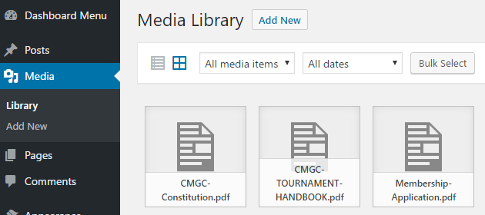

To update the PDF file, change to the list view and click on replace media:

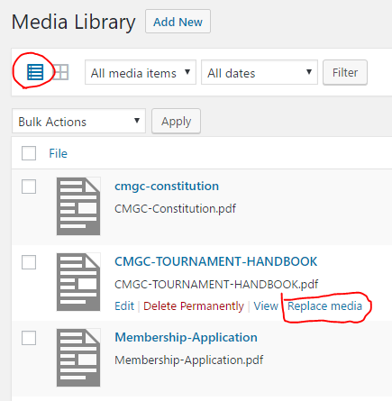

Click on choose file and select the updated file. Leave the selection at **Just replace the file** and click Upload. (The **replace the file, use new file name and update all links**, doesn’t update menu items, so don’t use this option.)

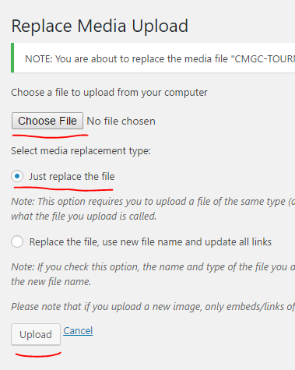

After you click upload, you are done. You can update the Caption if needed (and click **Update** on the right). If you viewed the original PDF and then you try viewing it again after your update, you may have to click on the refresh button in the browser, since the browser may be showing you the original PDF which it cached when you looked at it the first time.

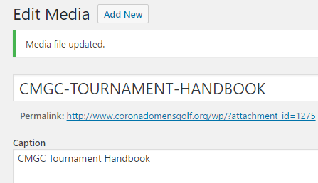

Click on the **Media** button on the left to return to the full list of media files.